# Navigator PHP and IFS Walkthrough

Last updated: January 31, 2013

# Background:

* The environment:
  + LMe 6.2A on ALDMO1
  + Navigator PHP Application
    - Development: C:\Development\Navigator
  + A QA version of the Navigator is in the IFS here: \\QALDMO1\root\www\zendsvr\htdocs\Zend_Navigator_Demo_QUA
  + The Live version of the Navigator is in the IFS here: \\QALDMO1\root\www\zendsvr\htdocs\Zend_Navigator_Demo_PDN

# Pre-Demo

1. Choose your IDE
   * Use Notepad.
   * Or use Zend Studio for Eclipse
     + C:\Program Files (x86)\Zend\Zend Studio 9.0.3\.
     + Workspace c:\development
2. You can download Zend Studio for Eclipse at the Zend website.
   * More information on the ZSE can be found here: steps 2 and 3 of the “Getting Started with Zend PHP and Aldon LM” document: \\rocketsoftware.com\channel\Aldon\Sales_Engineering\Knowledge_Lead\PHP
   * License Key: 226AFD09C364256D4A00991CC5B724F35B0D795BE4F01B9C081183D0552CA9E2CCE2F380379538C8D0D7E7D2A0F9F30C6973431AB6A6538E6D75E8C0CA46F3BD425A2D30303B30302F30302F303030303B392E303B3030313B323B3637
   * Serial number: SN9C2A348D09018261551
   * Expiration date: Perpetual
3. Make sure you can access the Zend Navigator application
   * Test: <http://172.25.8.113:10088/zend_navigator_demo_QUA/login.php>
   * Live: <http://172.25.8.113:10088/zend_navigator_demo_PDN/login.php>
4. If the page does not start, see the instructions in the “Start Up Zend” document at \\rocketsoftware.com\channel\Aldon\Sales_Engineering\Knowledge_Lead\PHP
5. OPTIONAL, Link with LMi:
   * Use **ALDON/WHOLESALE/BASE** if you want to show a combination of PHP and RPG changes in your walkthrough.
   * While it does not have anything directly to do with the Zend Navigator web application, is shows that LM can promote both the php artifacts and the i5 artifacts that would need to be managed together in a typical i5/PHP application.
6. Open up the following items in your browser window:
   * Test Zend Navigator
   * Live Zend Navigator
   * Community Manager
   * Web Portal
   * Jenkins for Navigator
7. Open LMe 6.2a and navigate down to Operations/Navigator/Base(1.0)

# Demonstration of Aldon

## Step 1: Show what we will be changing:

1. Show the web site for the QA and Live versions of Navigator. We will be changing the main entry page to add/remove the “Demo” watermark on the screen. 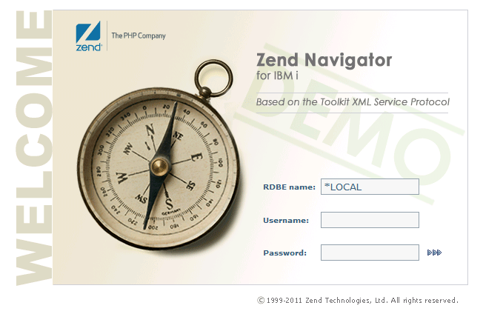

## Step 2: Create the Issue in CM

1. Create issue as end user
   1. From the Customer CM portal create an Issue in CM (_DEVELOPMENT MANAGEMENT Project)
   2. Title: Add/Remove Demo watermark
   3. Type: Enhancement
   4. Product: Navigator
   5. Version: 2
   6. Urgency: Not Urgent
2. Approve the request from Agent
   1. Switch to your agent CM tab
   2. See task in the “Dev Request” status.
   3. Edit the issue, and Link the issue to **Operations/Navigator/Base(1.0)**
   4. Approve the issue. This will change the status to ‘DEVELOPMENT’ and the assignee to ‘Jon’

## Step 3: Change the Code

1. Switch to Zend Studio (or work directly in LMe)
2. Explain that LMe is plugged in to Zend Studio and is providing the version control.
3. Check out ControlFile.txt and LoginPage.PHP to the task.
4. Change ControlFile.txt
   1. Change the first line Issue Number
   2. Change the second line Issue Number
5. Open LoginPage.php.
6. We will be toggling the line that sets a variable which contains the address of the gif file that gets loaded as the background image. In PHP, you comment lines by using the “//” marks. Simply remove the “//” from one var line and add it to the other.
7. 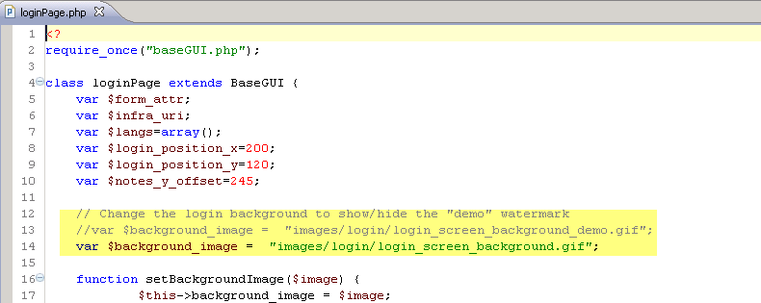
8. Check both items in. This promotes them up to QUA (no INT in this app!)

# Step 4: Publish, Import, Promote and Deploy to QA in one step!

1. Switch to the LMe Web Portal and show the deployment of the code over to WAL-VM-BUILD.
2. Switch to the Jenkins web browser and show the QA job running.
3. This will
   1. Clear the target directory of any leftover artifacts from the last deployment.
   2. Install the new code into the development staging directory C:\Development\Navigator
   3. Call Jenkins to a do a build
   4. Import the build and deploy to QA IFS directory on IBM i.
   5. Send emails.
   6. Update (via email) the CM ticket to “Passed QA” with updated subject and attachment.
4. Switch over to the LMe Web Portal and show the deployment happening to the QA IFS server.
5. Switch to Outlook and show emails to CM and Promote folders
6. Return to the QA URL and refresh the screen to show the changes.
7. Switch to CM and show:
   1. Status of task is now Production Ready
   2. Attachments from “automated testing”
   3. Approval pending for promote into Production

## Step 5: Promote to Production

1. Switch to Outlook and find the CM approval waiting message.
2. Reply to approve.
3. Switch to Web Portal and Jenkins.
4. Show the corresponding deployments to the build server in web portal, the build job running in Jenkins and then the final deployment of the changes to the production IFS.
5. Switch to the Production URL to show it has now changed.
6. Optional: show a deployment rollback.
7. Optionally, show RM reports.